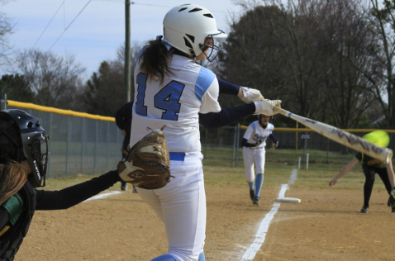

**Who: Girls 11-18 years of age**

**What: Home Run Derby**

**When: March 30, 2014 10 a.m. – 3 p.m.**

**Where: First Colonial High School Softball Field**

*The winners of each age bracket will receive the new model xeno!!*

Bring your own tosser, or use a designated one!

Homers for Childhood Obesity

RSVP at madisonkinglsa.weebly.com